User Interface Design & Specification

Climate & Weather

Confidential and Proprietary Information
This document contains information that is proprietary to Monash University. Transmittal, receipt, or possession of this document does not express license, or imply rights to use, sell, design, manufacture, or to have manufactured, any product, concept, or service from this information. No reproduction, publication, or disclosure of this information, in whole or in part, electronic or otherwise, shall be made without prior written authorization of an officer of Monash University
Authorized transfer of this document from the custody and control of Monash University constitutes a loan for limited purpose(s), and this document must be returned to Monash University upon request, and in all events, upon completion of the purpose(s) of the loan.

Document Change Log

Prepared By | Module | Date | Version
Simon Yu |  | 11/09/2010 | V0.1
Simon Yu |  | 17/09/2011 | V1

Revisions

Modified By | Reason | Date | Version

Table of Contents

1. Introduction 4
1.1. Purpose 4
1.2. Scope 4
2. Design Overview 4
3. Detailed Design 5
4. Site Structure and Navigation 22
4.1. Describe Different Types of Users 22
4.2. Workflow Diagrams 22
4.3. Alternative Workflows 34
4.4. Site Map 34
5. Help Screens 34
6. Non-Implemented Tasks 34
7. Summary 35

Introduction

Purpose
The purpose of this document is to outline the UI design of the Climate and Weather Data Capture Project and provide an overview for UI implementation of Climate and Weather Data Capture Project.

This document is not intended to address installation and configuration details of the actual implementation.

As is true with any high level design, this document will be updated and refined based on changing requirements.

Scope
The UI design outlined in this document builds upon the scope defined in the Requirement phase.

Design Overview
The user interface design focus on the user’s experience and interaction. The goal of user interface design is to make the user’s interaction as simple and efficient as possible. The user interface design must balance technical functionality and visual elements to create a system that is not only operational but also usable and adaptable to changing user needs.
Accessibility:
- Use semantic markup that provides a meaningful structure to the document (i.e. Web page)
- Provide text equivalents for any non-text components (e.g. images, multimedia)
- Use hyperlinks that make sense when read out of context.
- Use CSS rather than HTML tables for layout
- Use Ajax Technology
- Support different types of web browsers.
Consistency:
- Button in consistent places on all pages.
- Using the same wording in labels and messages
- Using a consistent color scheme throughout

Navigation:
- Navigation between major user interface items is important. Make sure the flow between screens matches the flow of the work the user is trying to accomplish.
- Navigation within a screen is important. The screens should be organized left to right and top to bottom, because people are used to do this.

Messages and labels effectively:
- Using full words and sentences, as opposed to abbreviations and codes, makes text easier to understand.
- Messages should be worded positively, imply that the user is in control, and provide insight into how to use the application properly
- Messages should be worded consistently and displayed in a consistent place on the screens

Detailed Design

Home Page of Climate and Weather
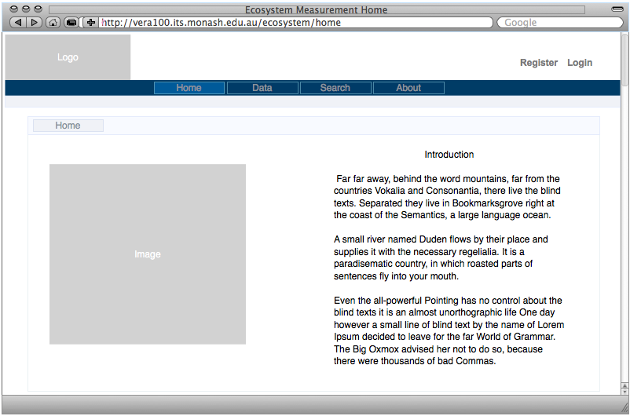

Registration Page
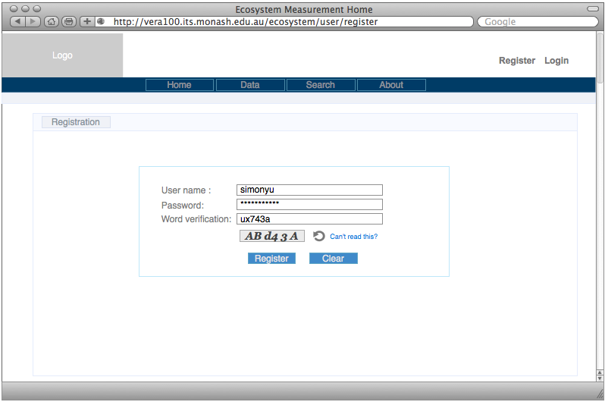

Registration Error Page
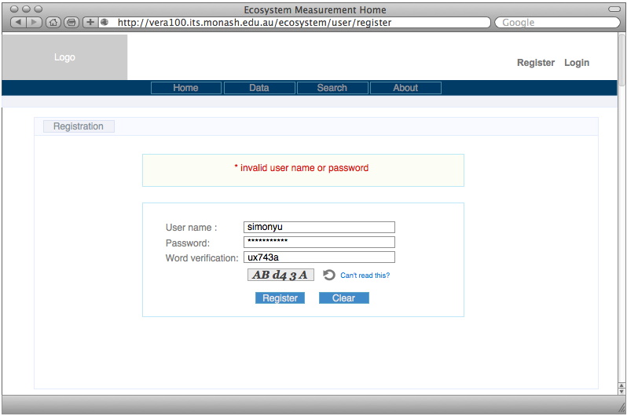

Registration Success Page
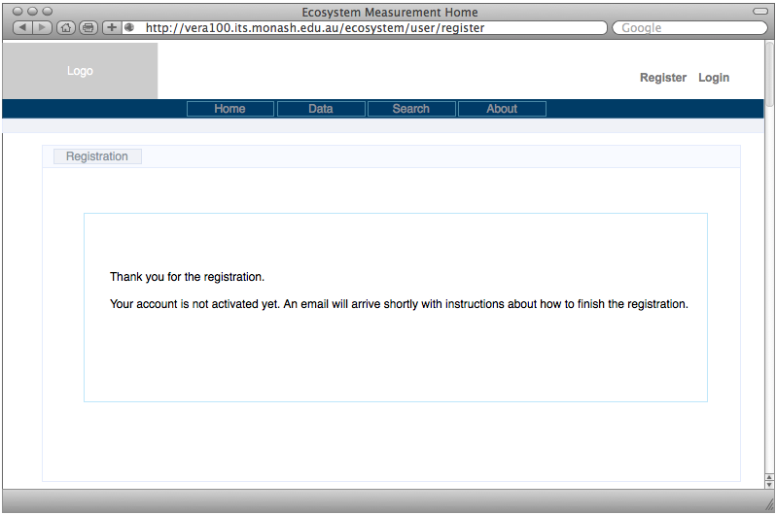

User Account Activation
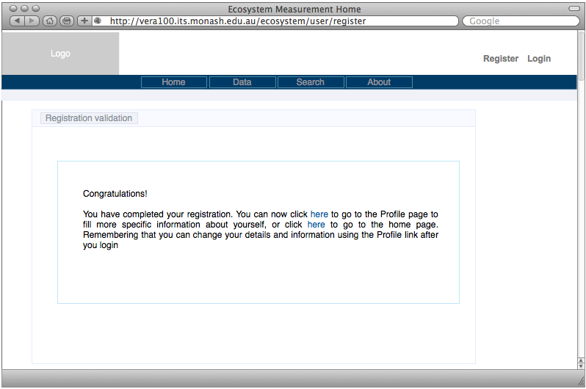

User Profile Page
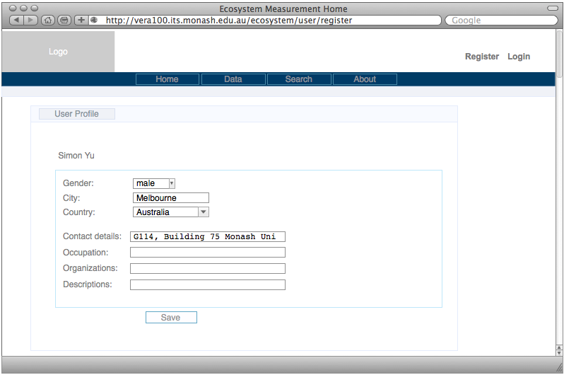

Login Page
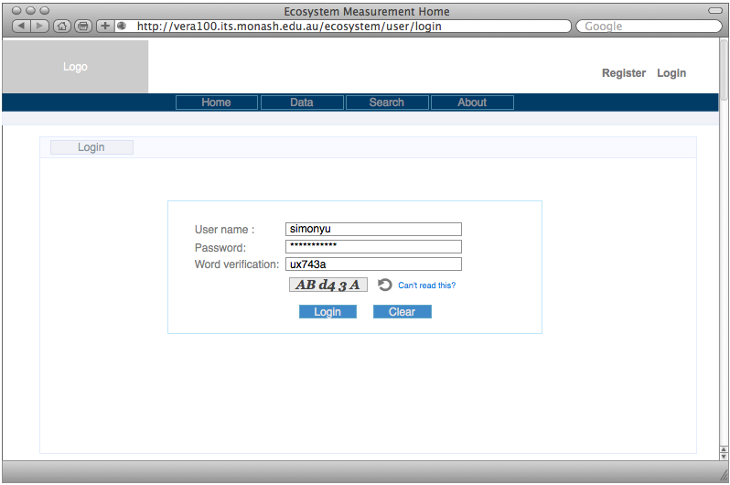

Login Error Page

View All Collections
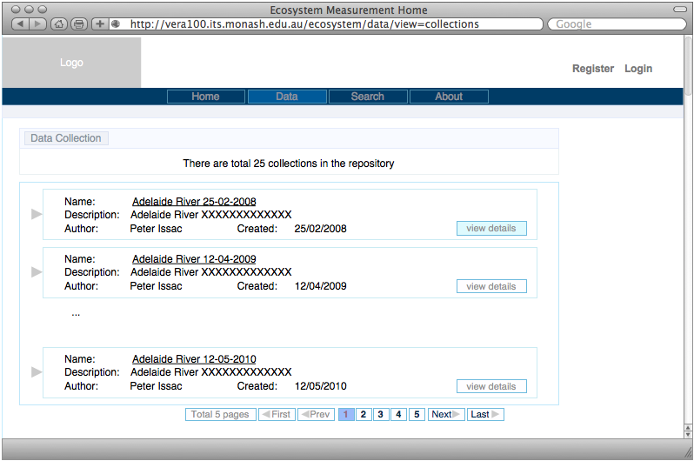

View Collection Details
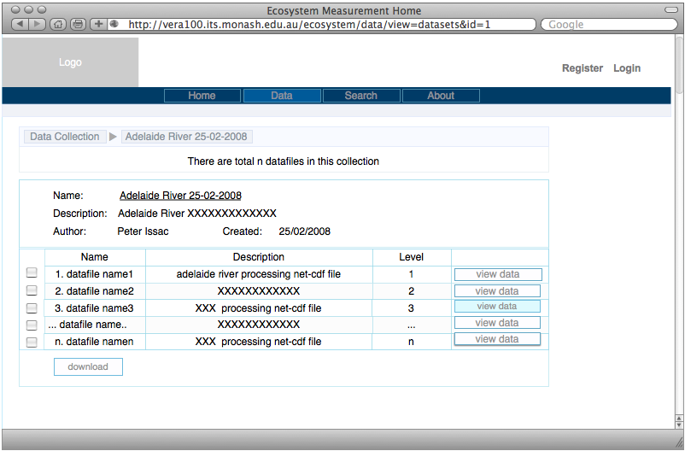

View Dataset
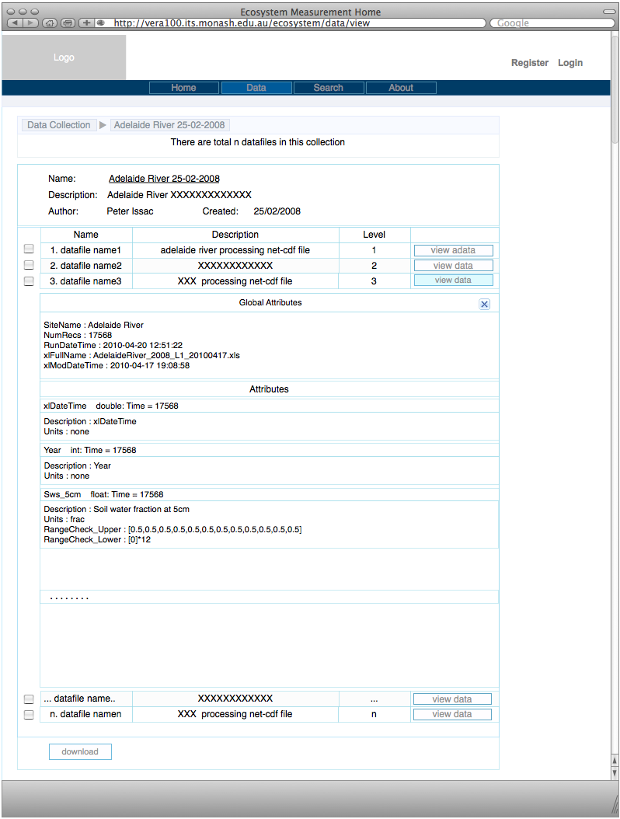

List User Collections
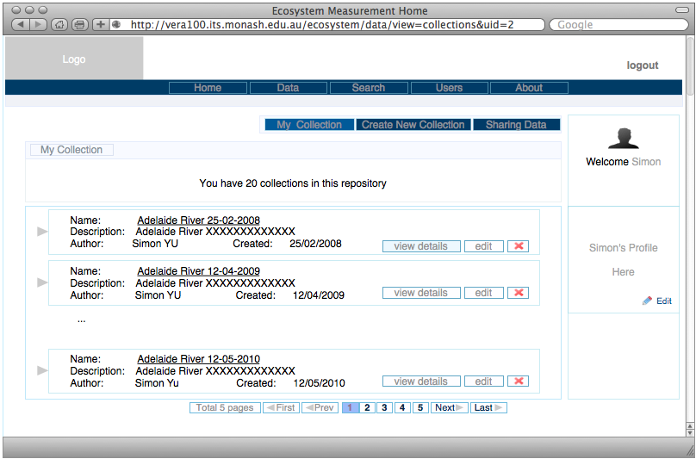

Create New Collection
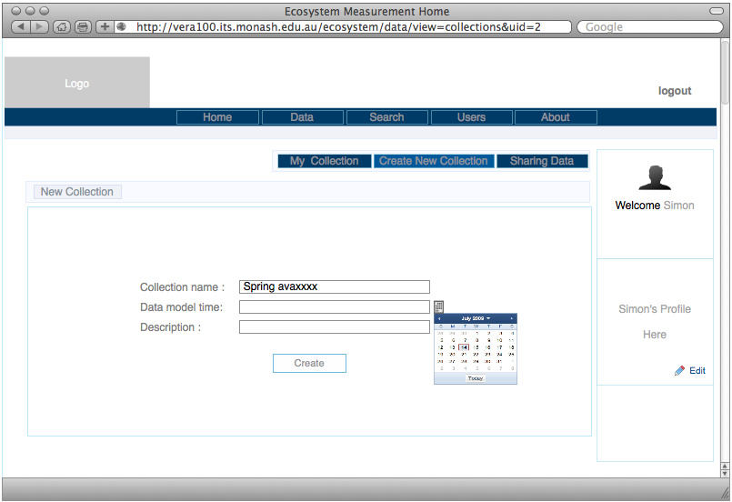

Modify Collection
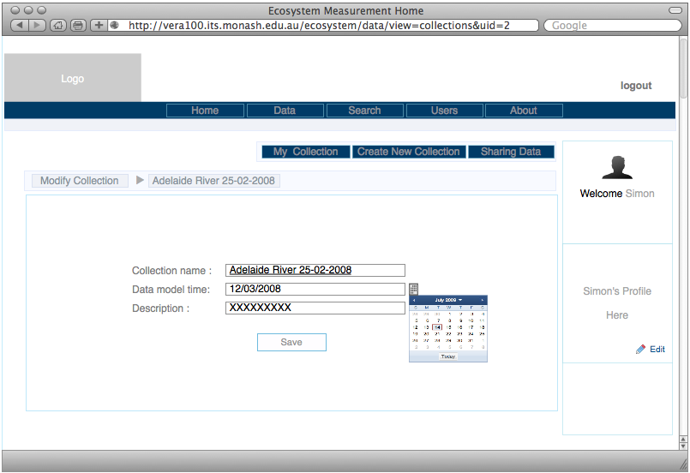

Delete Collection
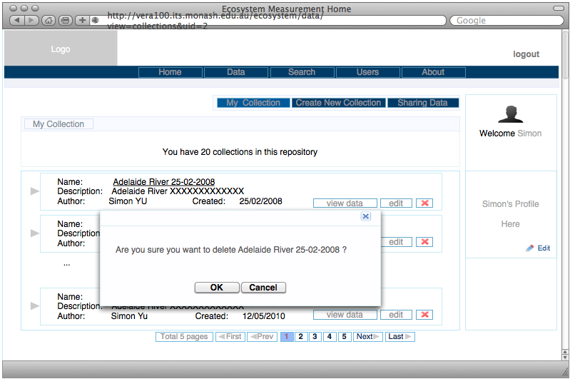

View User Collection Details
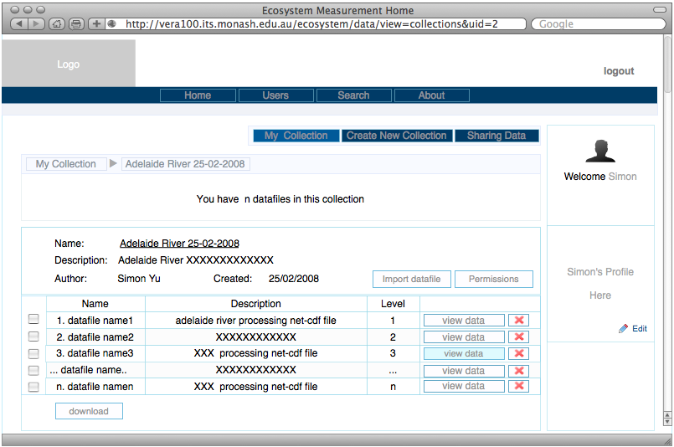

View User Dataset Data
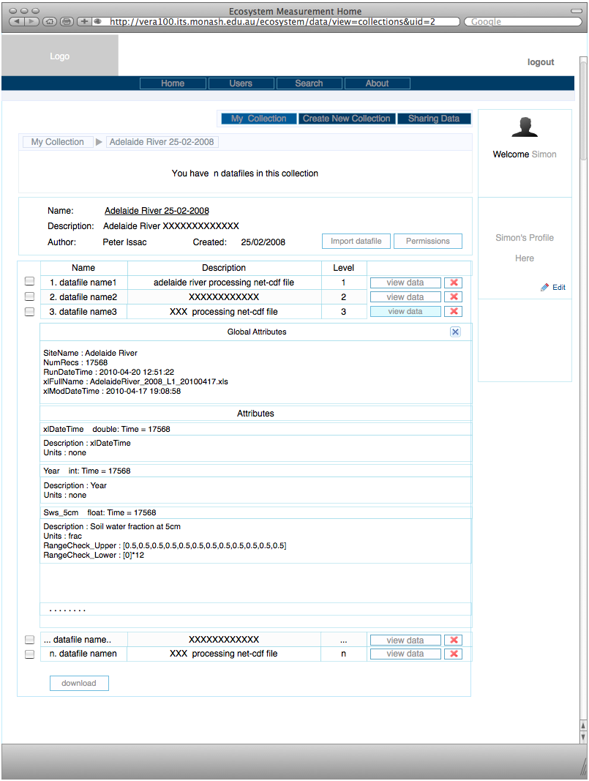

Delete Dataset File
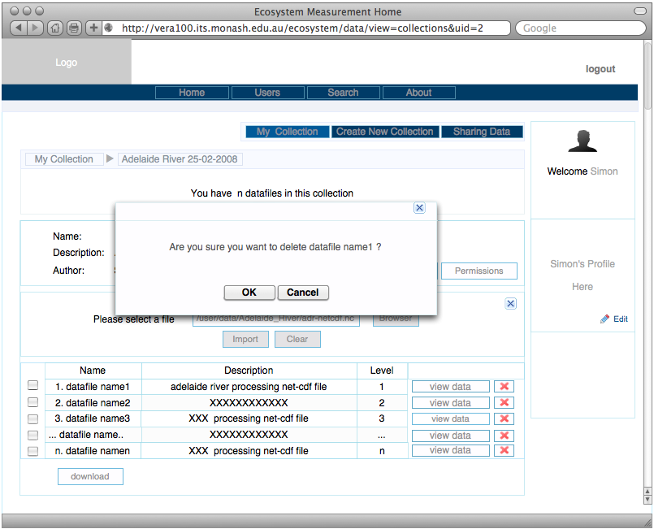

Import Dataset File
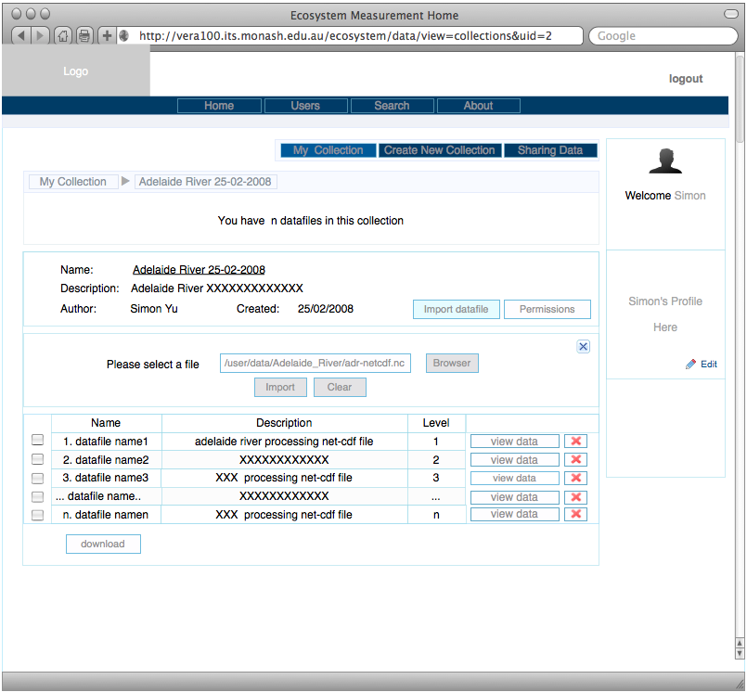

Assign Collection Permissions
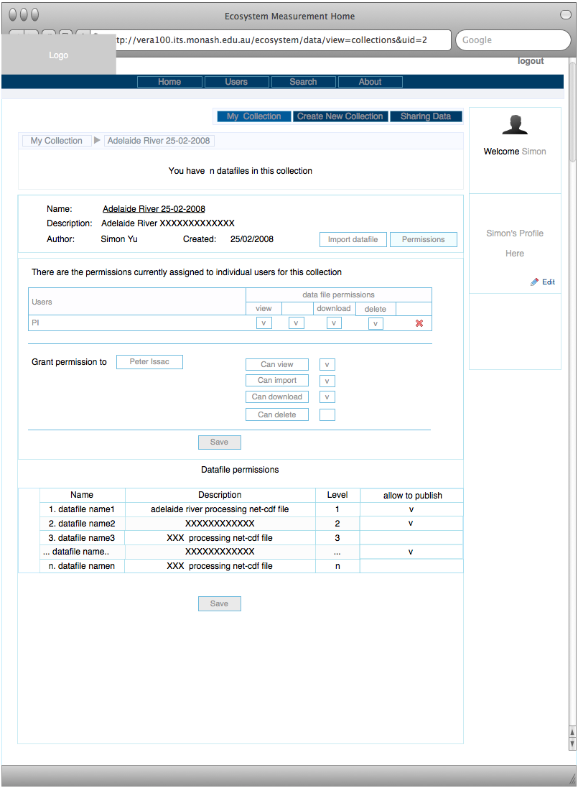

Updated Permissions
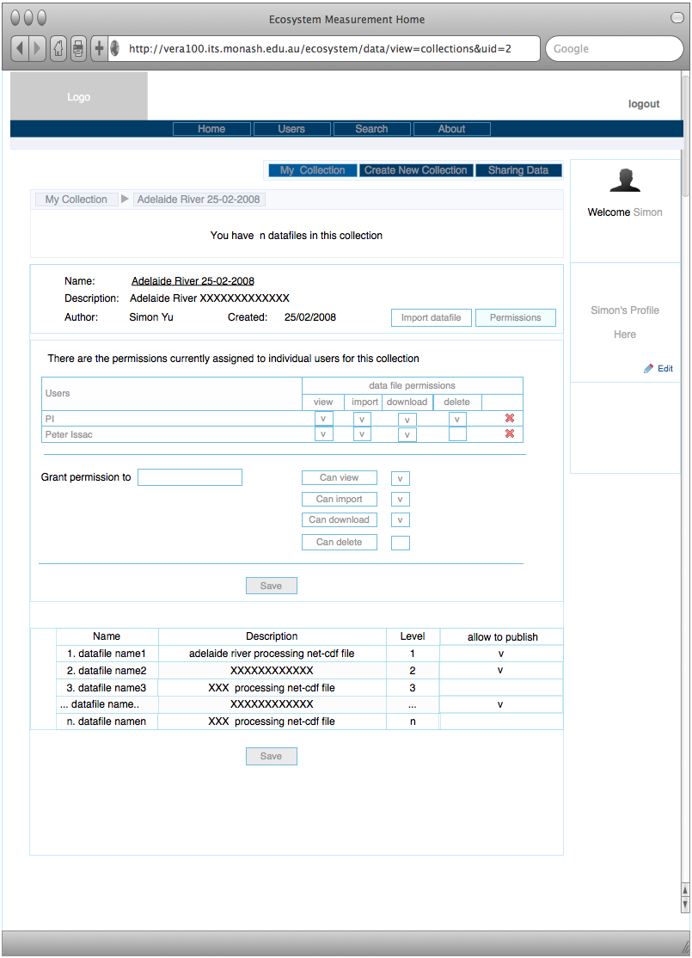

Remove Permissions
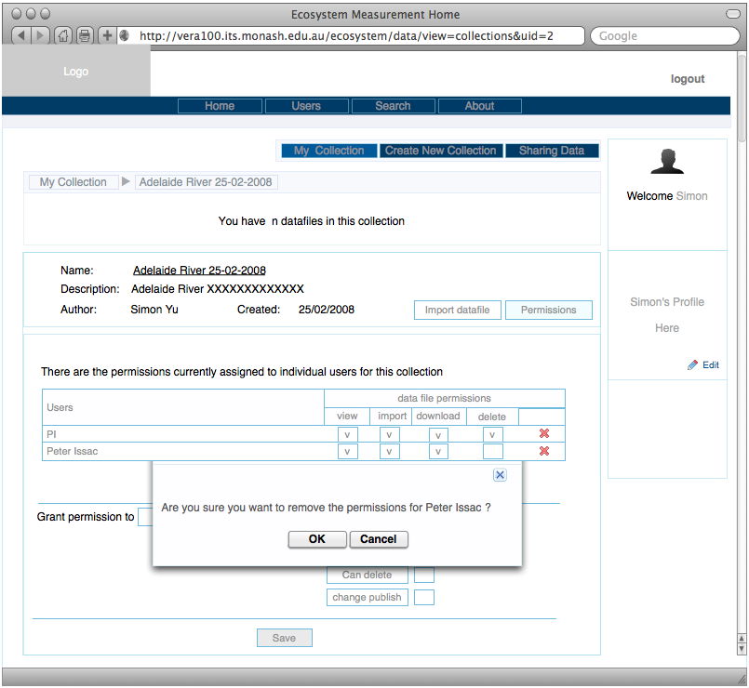

List Sharing Collections
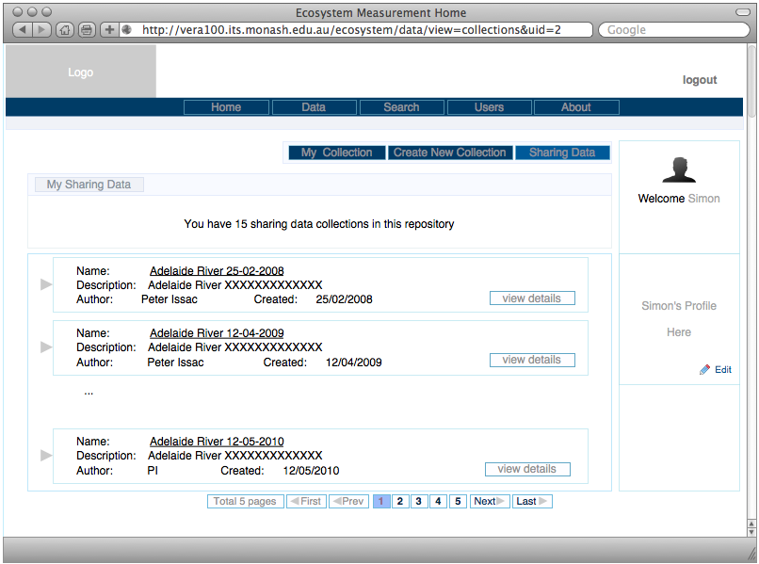

View Sharing Collection Details
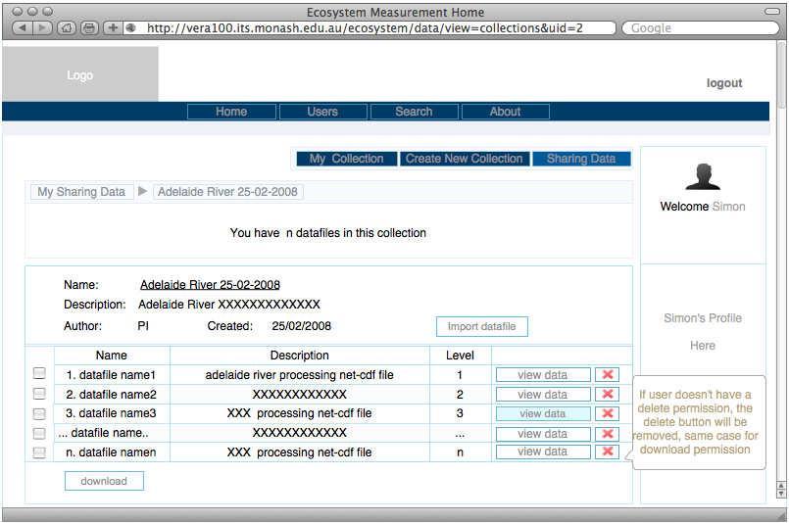

View Share Dataset Data
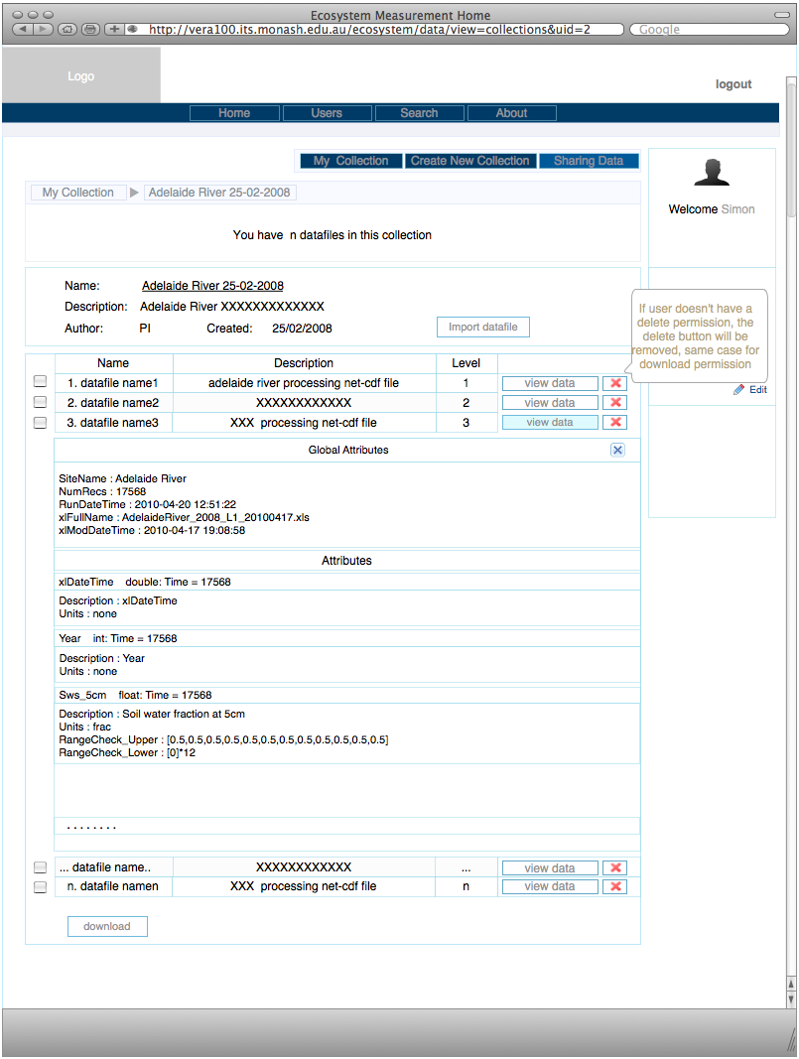

Search
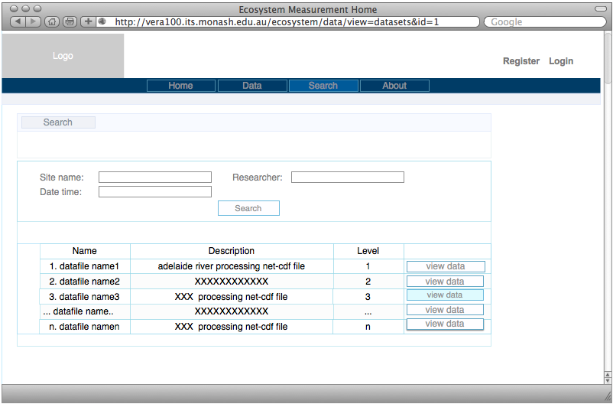

Site Structure and Navigation

Describe Different Types of Users
- Anonymous User
- LDAP User (Monash Authcate)
- Non-LDAP User (Self-registered)

Workflow Diagrams
- Register New User
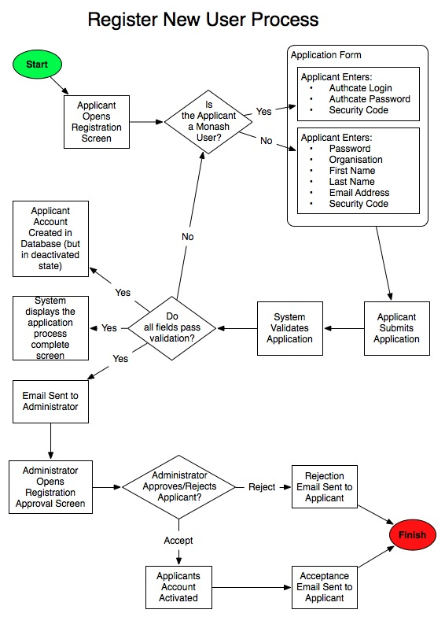
- User Login
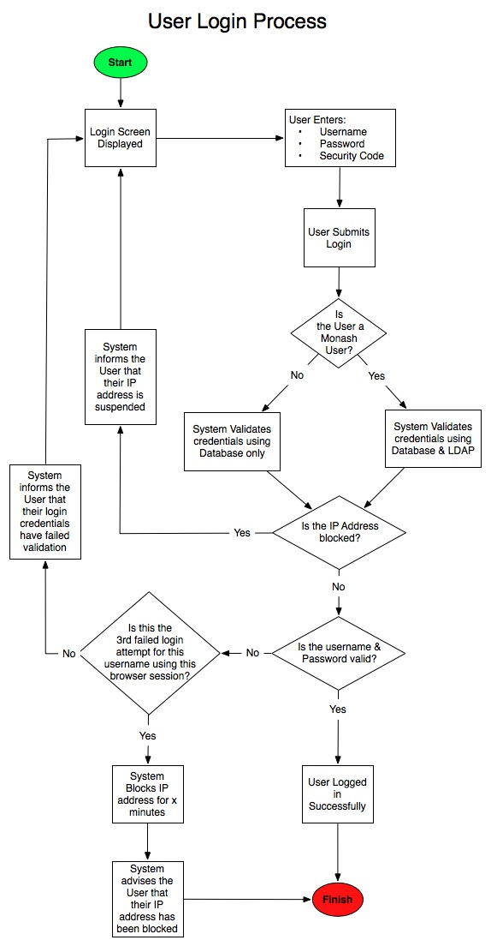

- Reset Password
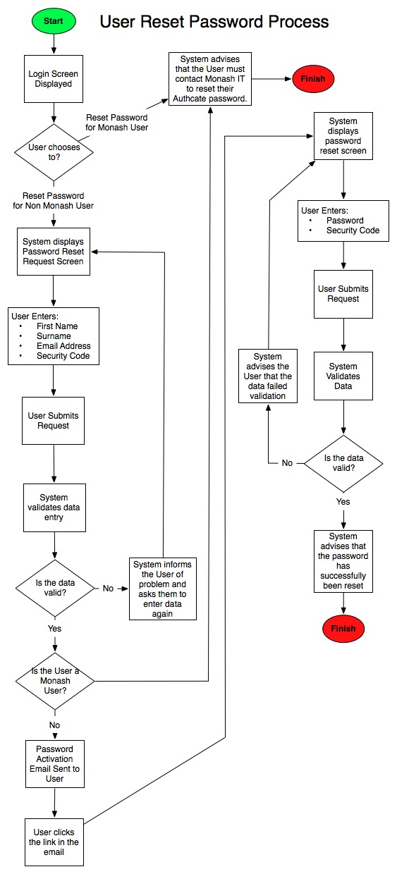

- Add, Edit Collection
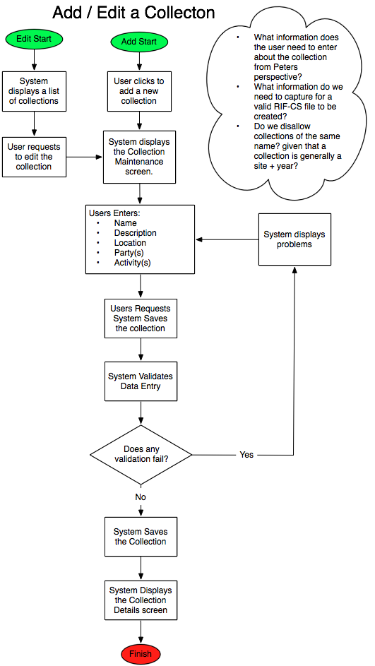

- View List of Collections
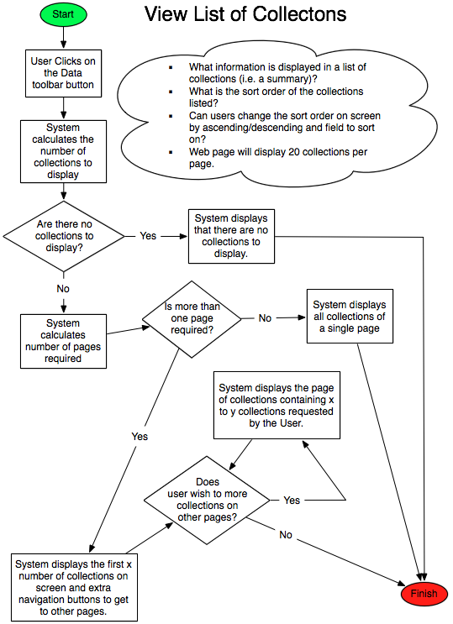

- View Collection Details
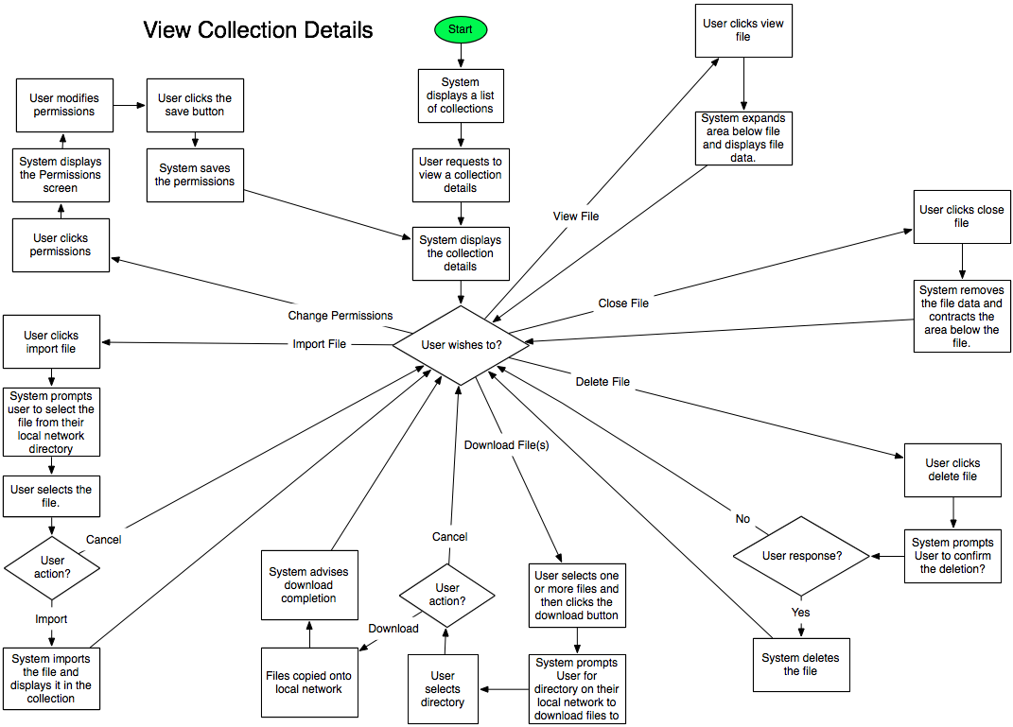

- Delete Collection
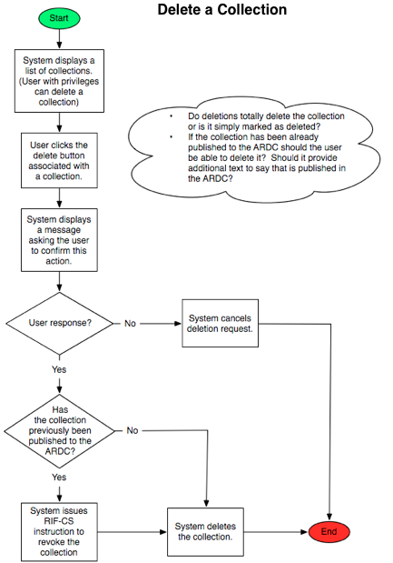

- Metadata Registration

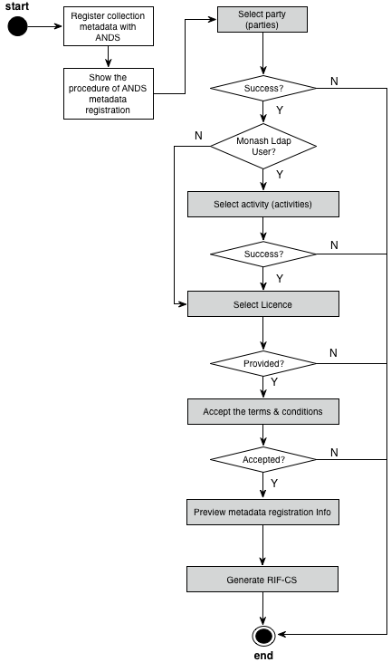

- Select a Party

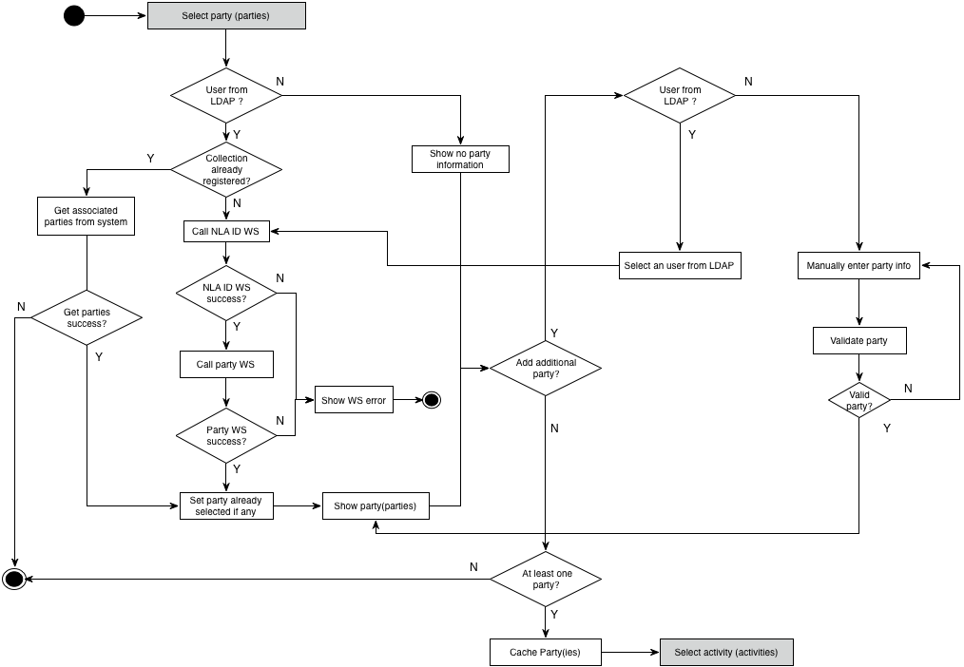

- Select an Activity

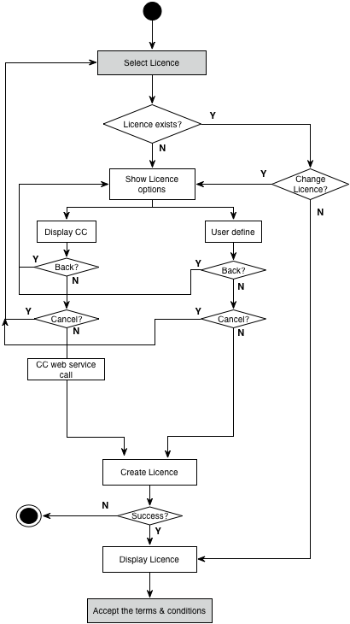

- Select a License

- Generate RIF-CS

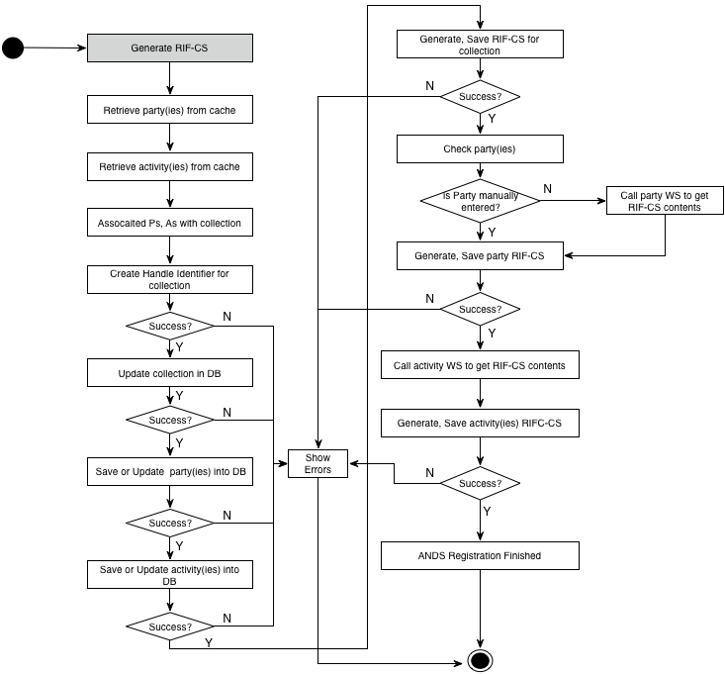

Alternative Workflows
N/A

Site Map
None. Using the Navigation bar instead

Help Screens
The Help Screens will be embedded in each individual pages which should the hints or instructions for every events

Non-Implemented Tasks
None.

Summary
The system will be built as part of the ANDS funded Monash ARDC-EIF Data Capture and Metadata Store Project. This project aims to develop software solutions that:
- Capture data and metadata from research instruments and devices
- Make available and automate feeds of data collection descriptions
- Enable data/metadata management and sharing
- Facilitate the re-use and discovery of data
- Recognise the need to facilitate the overall data stream/s from Monash to the RDA which include collections with related party and activity descriptions in compliance with the requirements set out in the ANDS Minimum Metadata Contents for RIF-CS

The struts2 framework, AJAX (JQuery) and Freemarker Template will be adopted in the Presentations layer, which makes the system components independent, easy maintaining and further developing.

